Device Deployment

Tyler Gardner & Raam Rattanakone

12/6/15

Project Documentation

We created an application that would allow for easier management of devices in our work environment. Currently in the work environment we have to manually search for each device in separate locations. We wanted to create a simplistic hub that would provide all the tools. Currently we have a secure login/logout, permission based pages (all pages require a log in), device search, server search, and a laptop reports.

Here is a walk-through of our project:

**Login:** Is reached through the home page. There are multiple ways to login as well as an option to create an account. The accounts are stored/saved in our database and persist. To test some of our features please use [raam@raam.com](mailto:raam@raam.com) pw: Testing1 and [tyler@tyler.com](mailto:tyler@tyler.com) pw: Testing2 (emails are case sensitive). You will also be able to create your own account. Email addresses are case sensitive to the left of the @ and to the right of it will have to be lowercase. There is also server/client side validation/security. There is also logouts that appear on the top left of the nav bar. Passwords also have character requirements.

**Permissions:** To go along with the user accounts there are permission based pages. You can see which ones are “Admin” required by switching between raam’s account and tyler’s account.

**Homepage:**

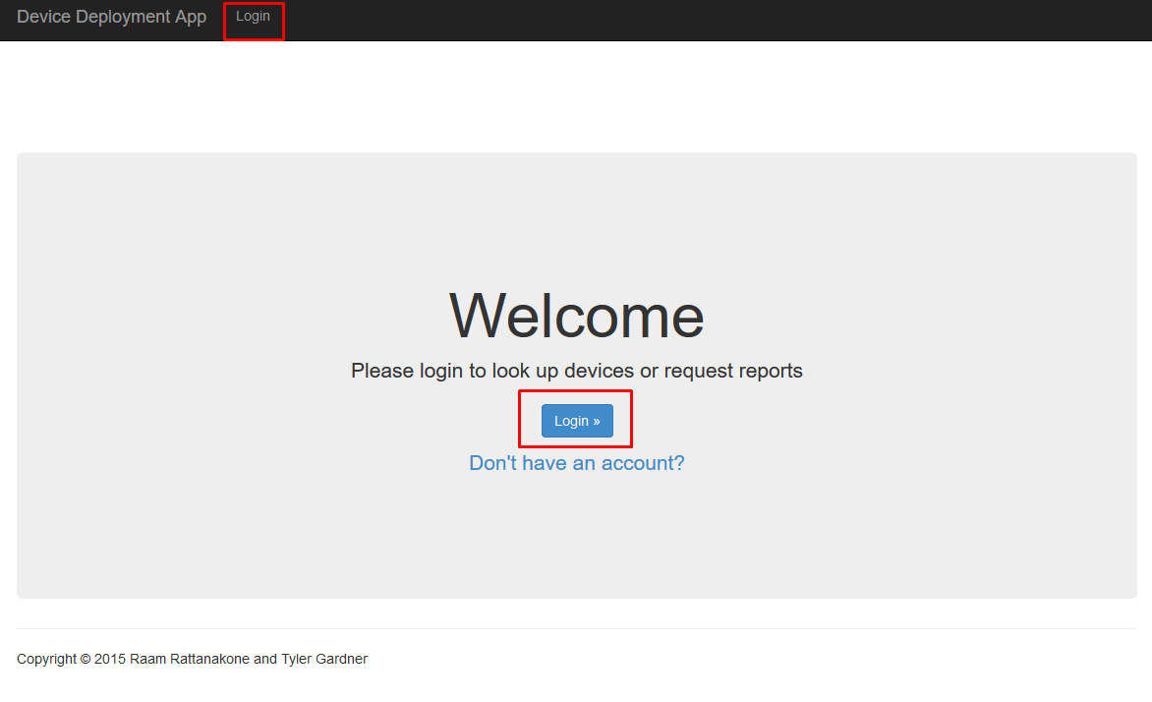

**Post Login Page:**

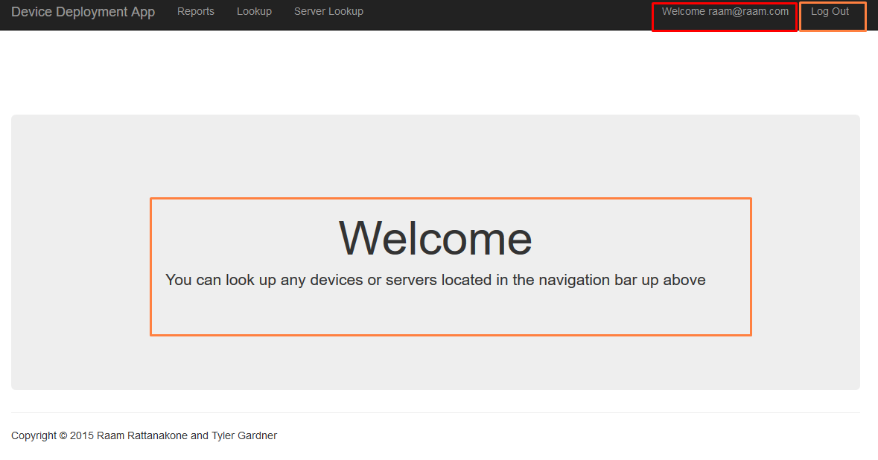

**Sign Up:**

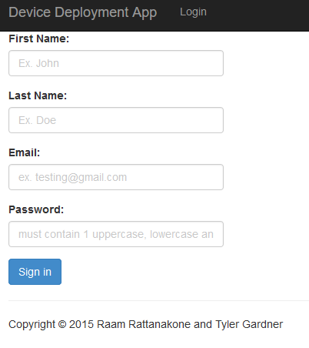

**Login:**

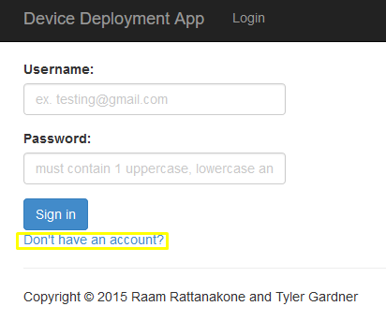

**Username Validation:**

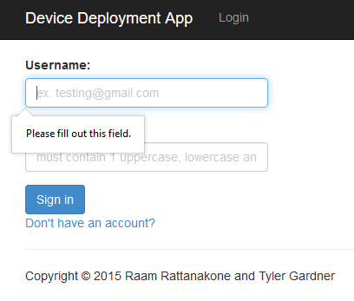

**Password Validation:**

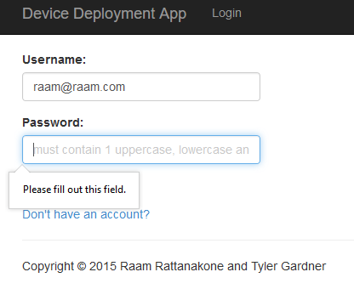

**Incorrect Password:**

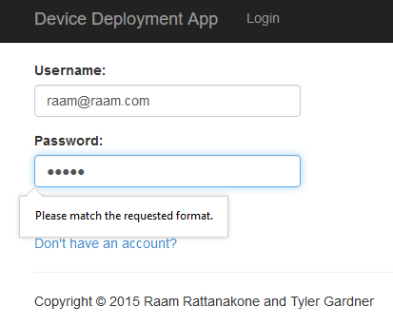

**Username Incorrect:**

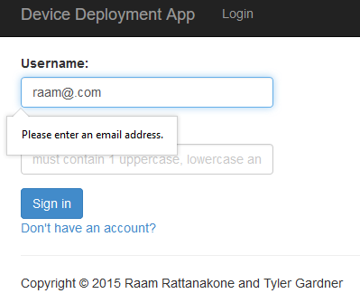

**Failed Login:**

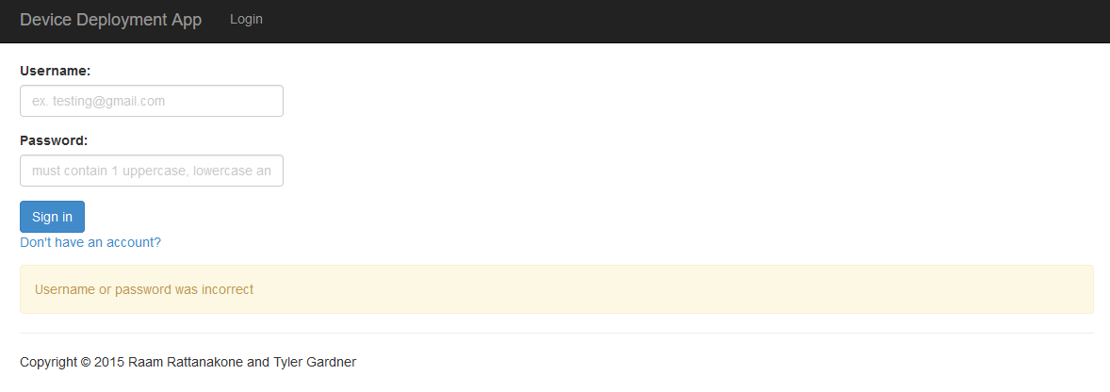

**User Permissions:**

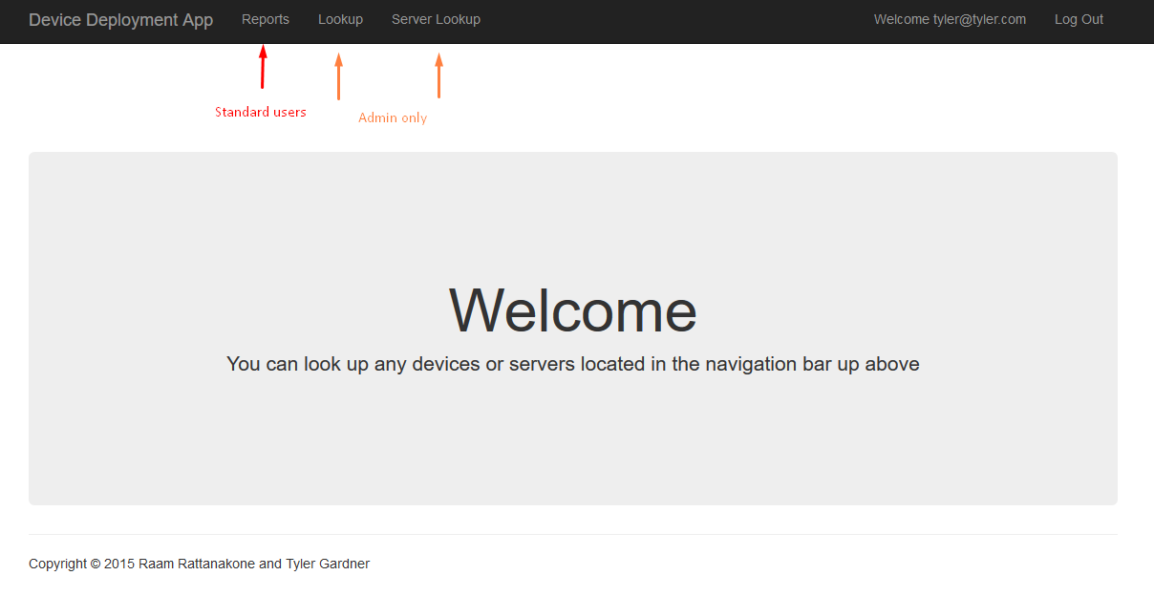

**Device Search:** Device search allows the administrative user enter a specific name. If the name already exists it will pull up the device name in a separate table.

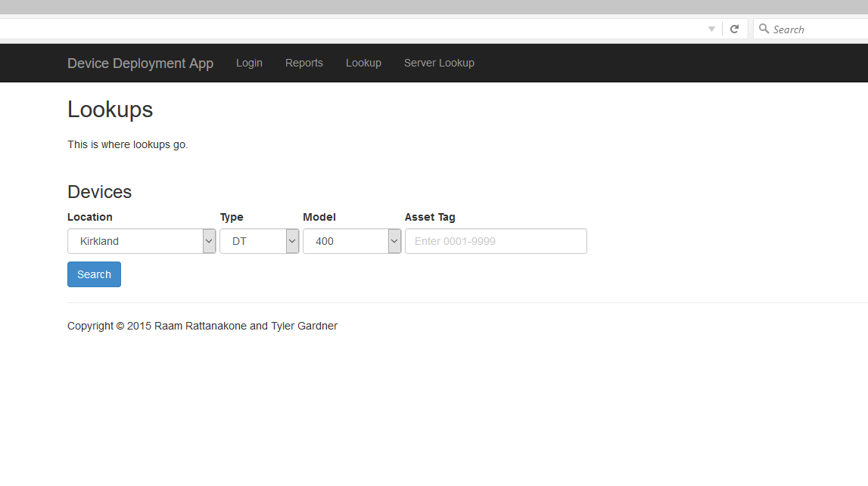

**Authentication:** There is client side verification for the Asset Tag field to prevent them from submitting the form incomplete.

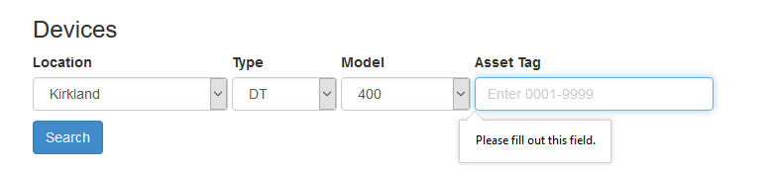

**Data Table:** When the user fills out all the fields and hits search, it will pull up the device.

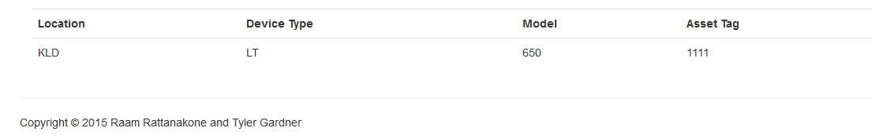

**Not Found:** If the device doesn’t exist this screen will pop up:

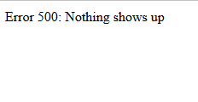

**Server Search:** Server search is almost exactly like device search, however server names are a different syntax. There are 5 drop down lists that are pre populated directly from our SQL server.

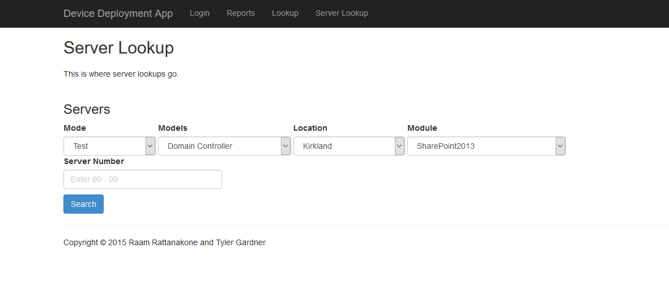

**Demo Search:**

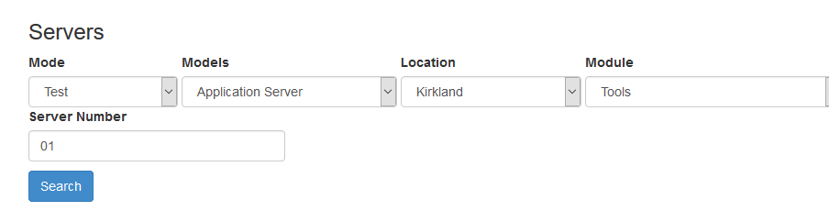

**Search Result:** Once the fields are filled out and if the server exists it will generate a table:

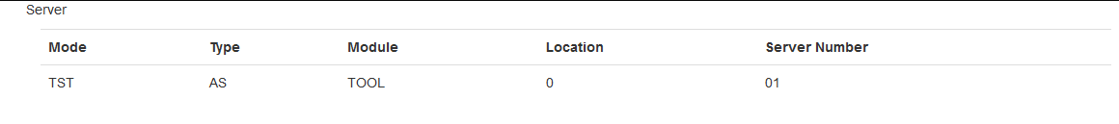

**Not Found:** If the device doesn’t exist this screen will pop up:



**Authentication:** There is client side verification for the Server Number field to prevent them from submitting the form incomplete.

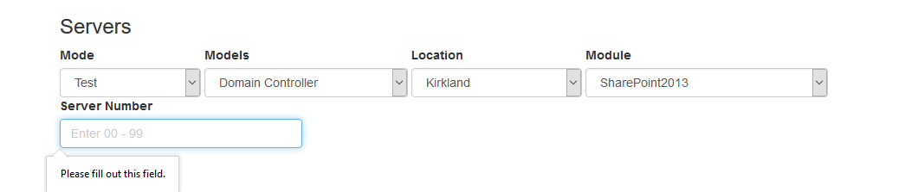

**Reports:** Generates a table based of generic search parameters that the user types in. Pulls up all the machines related to the device typed in. In the reports tab we have 2 buttons, one for each Device category. Each field in “Reports” is a require field. Capitalization also is a non-factor. The reports tab is open to anyone who has an account.

**Reports:**

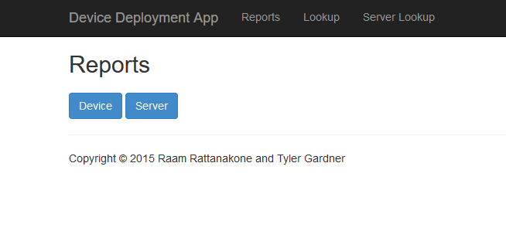

**Device Reports:** If they typed in “laptop” it would pull up all the laptops with the generic parameters the user typed. There are 3 devices currently: Laptop, Thin Clients and Desktops. The fields are set up to ignore capitalizations of all forms.

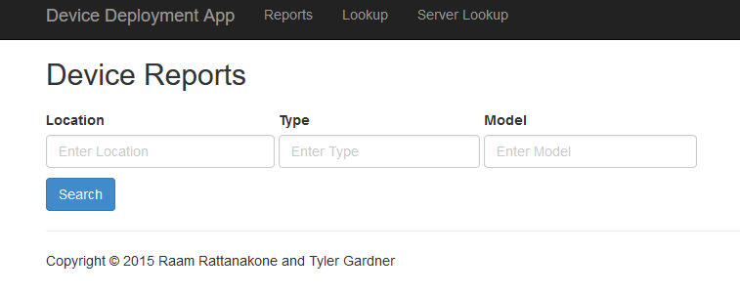

**Example of Search:**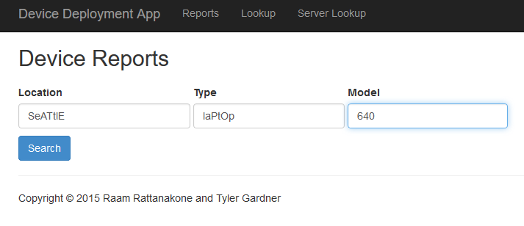

**Example of Fulfilled Report:**

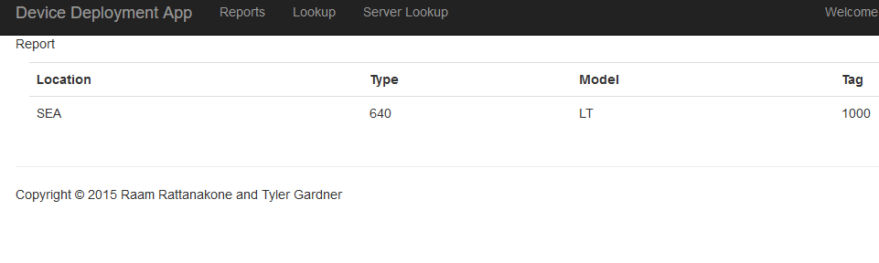

**Example of Server Reports:**

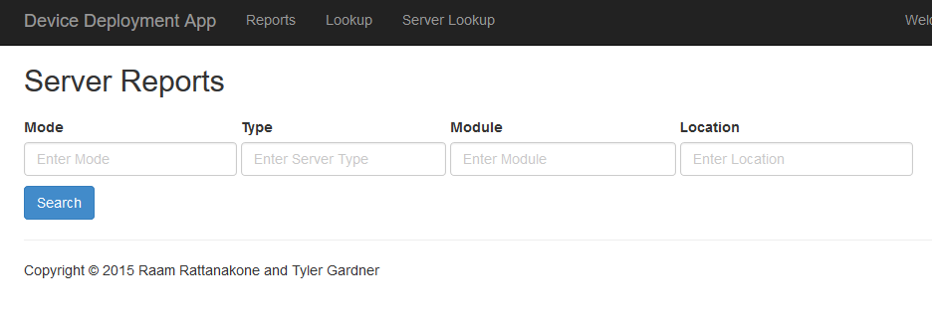**Example of Server Search:**

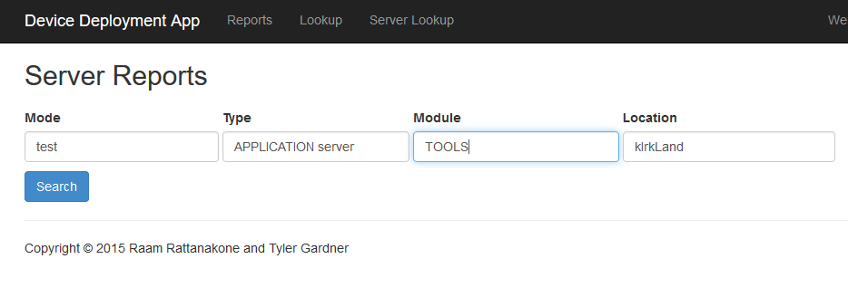

**Example of Fulfilled Server Report:**

